Chapter 7, Problem 87.

A 120-V dc generator energizes a motor whose coil has an inductance of 50 H and a resistance of 100 Ω. A field discharge resistor of 400 Ω is connected in parallel with the motor to avoid damage to the motor, as shown in Fig. 7.147. The system is at steady state. Find the current through the discharge resistor 100 ms after the breaker is tripped.

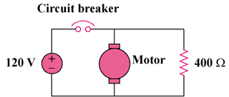

Figure 7.147
For Prob. 7.87.

